**Power Stage Calculations**

The battery voltage range is 2.5V to 3.65V per cell, 37.5V to 54.75V total (absolute max is 3.7V x 15S = 55.5V), and the capacitor voltage will charge up to a bit less than that. To avoid extreme duty cycles, the converter should only be capable of 3:1 voltage step up, which still removes 86% of the capacitor’s stored energy. The output current is up to 190A.

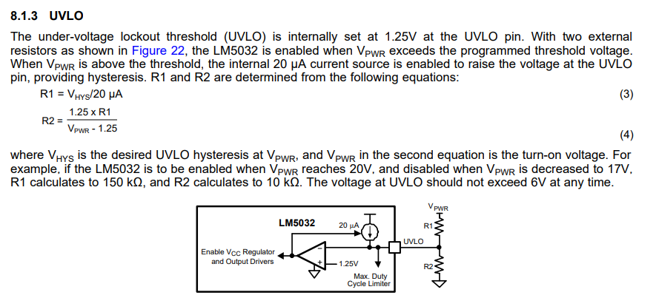

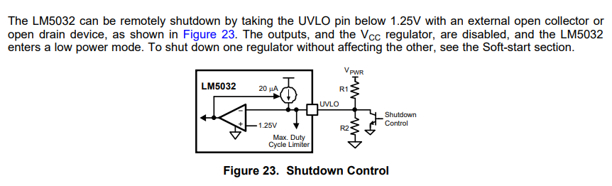

Output current up to 190A with up to 3:1 voltage step-up, IIN = 190A * 3 = 570A. Input voltage as low as 18V. Vout as high as 55V.

Switching frequency of 500kHz, interleaved to make it effectively 1MHz for the capacitors RLoad = VOut/IOut = 3.2*15/190 = 0.25 ohms

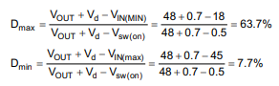

DMin = 0

DMax = 1 – [(18 * 0.85) / 55] = 72.2%



Peak IOut = 95*2 = 190A

IL(avg) = (0.5 * 190A) / (1 - 0.722) = 341.7A ***note this is per phase so x2 is IL(avg) total

△IL = (18V * 0.722) / (500000 * 470 * 10-9) = 55.3A

I(Peak) = 341.7 + (55.3 / 2) = 369.4A ***note this is per phase so x2 is I(Peak) total

LMin = (18V * 0.722) / (500000Hz * 53.3A) = 488 nH

ICap-RMS = 0.7*190A = 133A

Use 4 x 10uF capacitors, X7R loses 10% of capacitance at 1 MHz, DF = 2.5%

ESR = DF/(2π*f*C) = 0.025 / (2 * 3.14 * 1000000Hz * (10 * 10-6F)) = 0.0004 Ω

***per capacitor

PCap = (133/4)2*0.0004Ω = 0.489 W



ΔVOUT = [(190A * 1) / (8 * 10 * 10-6 * 2 * 500000)] + [(369.4A * 0.0004 Ω) / 4] = 2.41V

Additional ΔVOUTdue to ESR:

ΔVOUT(ESR) = (0.0004 Ω) * [(190A / (1 – 0.717)) + (48.8A / 2)] = 0.28V

IN = 54 / (0.47 * 0.5) = 230A

IRipple = 0.35 * IN = 0.35 * 230A = 80.5A

Again, use 4 x 10uF

PCap = (80.5A / 4)^2 * 0.000442Ω = 0.179 W

PFET = 190A / (2 * (1 - 0.673)) * 0.0011 * 0.717 * 1.3 + 12 * 0.178 * 0.5 = 1.35 W

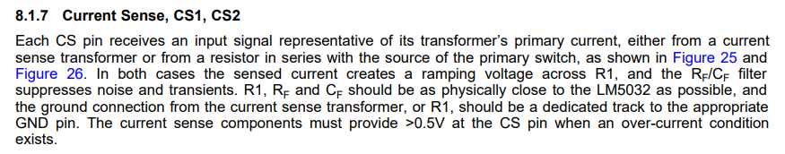

Calculating necessary current-sensing resistor value:

V = I*R = 369.4A * 0.0001Ω = 0.037

P = I*I*R = 369.4A * 369.4A * 0.0001Ω = 13.65W

Heat Transfer from PCB through silicon thermal pad to cooling block

Q(t) = (kAΔT) / L

Q = [(0.9W/m-k) * (0.108m * 0.1143m) * (30°C)] / 0.000178m = 1872W